Using “Resume Assistant” powered by LinkedIn in MS Word
- Log into your Wake ID Portal
- Open Microsoft Word Office 365 ProPlus
- Click “new” 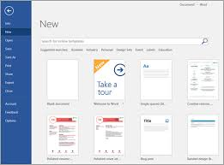
- In the template search box – type “resume”
- Choose a resume template & click “create”
- Using the ribbon at the top, click on the “review” tab 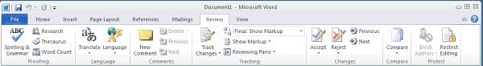
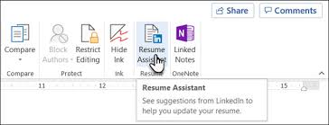
- Click “resume assistant”-this will open a navigational pane on the right side of your screen

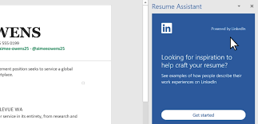
- Click the “Get Started” button in the navigational pane for Resume Assistant
- Enter a role and industry in the boxes provided – this will pull information from LinkedIn profiles based on the information you entered
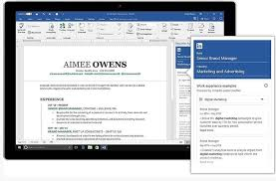
10. Using the examples provide from LinkedIn profiles in the navigational pane, enter your work, internship or volunteer experience. The examples shown will provide you with a guide of what to type and how to set it up. Note: you can also filter the examples. Example: Filter by “top Skills.”
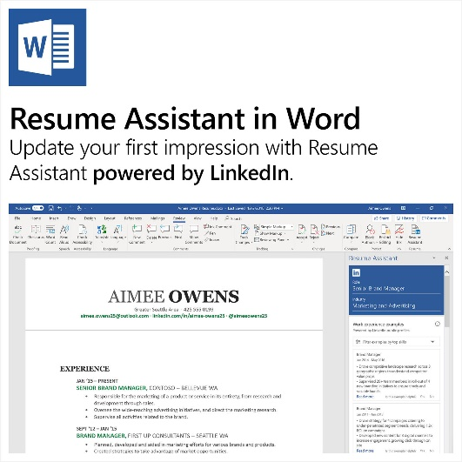
Other things you can do using Resume Assistant:
- View articles that relate to the industry you specify.
- See a list of skills for any occupation that you specify.
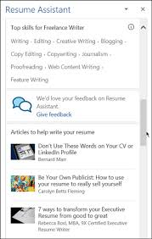
- View available jobs in any industry that you specify.
- Click the link to go to LinkedIn and setup an online profile.

Note: When you resume is complete, you can add it to your LinkedIn profile so that others may view!

