Step 1- Create an FSA ID
Go to FSAID.ED.GOV
Student: An FSA ID is a username and password you need to log in to and sign the FAFSA online.
- Under ‘Create an FSA Account” enter required information.
- Please know or have access to:
  - your Social Security Number ahead of time.
  - Please have access to a valid, working email address
  - Helpful hint: use an email that is NOT your school email
Parent: If your child is required to report parent information on the FAFSA, YOU NEED TO CREATE YOUR OWN FSA ID (following the same steps listed above) in order to sign your child’s FAFSA online and have access to the IRS Data Retrieval Tool (DRT) . Parents are able to use their FSA IDs right away.
Step 2-Start the FAFSA
Go to FAFSA.ED.GOV
- Student:
  - Click “Start A New FAFSA”
  - Click “Enter your (the student’s) FSA ID”, enter your FSA ID username and password, and click “Next”.
Choose which FAFSA you’d like to complete:
- 2017–18 FAFSA if you will be attending college between July 1, 2017 and June 30, 2018.
*Remember, the FAFSA is not a one-time thing. You must complete a FAFSA for each school year.
Create a Save Key
- Unlike the FSA ID, the save key is meant to be shared. A save key is a temporary password that allows you and your parent(s) to “pass” the FAFSA back and forth. It also allows you to save the FAFSA and return to it later. This is especially helpful if you and your parent are not in the same place.
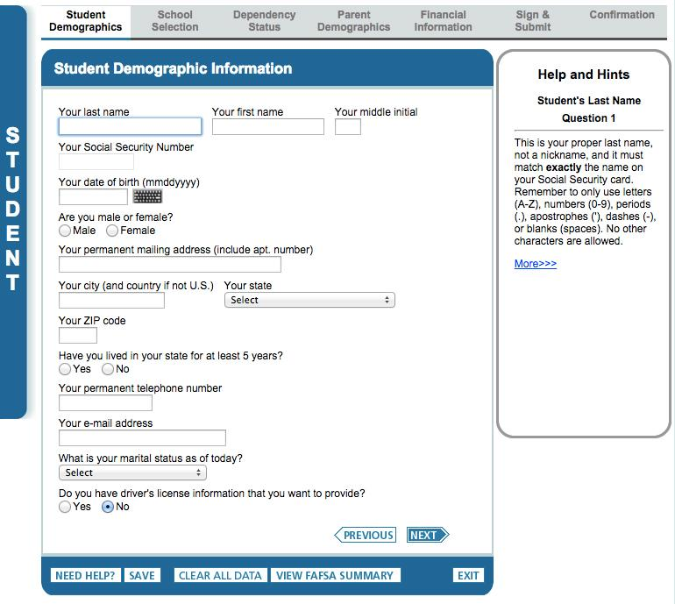
Step 3- Student Demographics
Students: This is information like your name, date of birth, etc.
- Make sure you enter your personal information exactly as it appears on your Social Security card. (That’s right, no nicknames.)
- If you are a male and you have not registered for the Selective Service (draft) you will select “no”, then “Register Me”
Step 4- School Selection
Students: You are allowed and encouraged to add every school you’re considering, even if you haven’t applied or been accepted yet. You can add up to 10 at a time.
1 : Click “Add A School”
Option 1- School Search  - Enter State  - Then enter the CITY your college is in  or  enter the School Name | Option 2- Federal School Code  This can be located on your school’s website or Google  Vance-Granville Community College Federal School code is: 009903

2: Click Search > Select school > Add
You know you are complete when your school is on the right side of the screen underneath “Selected Schools” option.
Step 5- Dependency Status
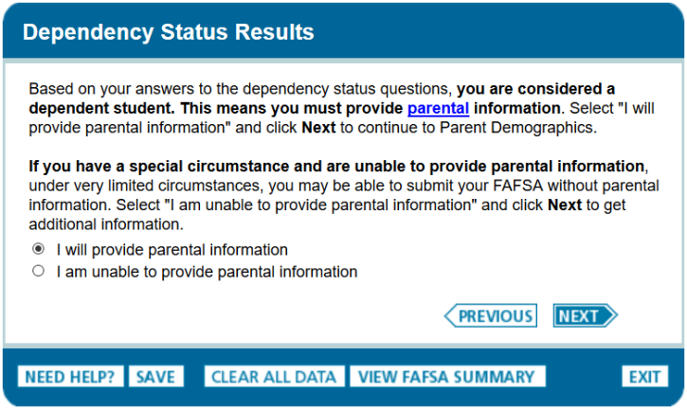
Students: In this section, you’ll be asked a series of specific questions to determine whether or not you are required to provide your parent’s information on the FAFSA.
- Even if you live on your own, support yourself, and file taxes on your own, you may still be considered a dependent student for federal student aid purposes.
- If you are determined to be a dependent student, you’ll be required to report your parent’s information.
- If you’re determined to be an independent student, you won’t have to provide your parent’s information and you can skip the next step.
Step 6- Parent Demographics
Parents: This is where your parent(s) will provide basic demographic information. Remember that it doesn’t matter if you don’t live with your parent(s); you still must report information about them if you were determined to be a dependent student in the step above. Start by figuring out who counts as your parent on the FAFSA.
FAFSA WHICH PARENT TO USE
Biological Parents/Adoptive Parents
Biological Parents/Adoptive Parents | · If your legal parents (your biological and/or adoptive parents) are married to each other, answer the questions about both of them, regardless of whether your parents are of the same or opposite sex.  · If your legal parents are not married to each other and live together, answer the questions about both of them, regardless of whether your parents are of the same or opposite sex.  · If your parent is widowed or was never married, answer the questions about that parent.
Divorced/Separated Parents Who Do Not Live Together | · If your parents are divorced or separated and don’t live together, answer the questions about the parent with whom you lived more during the past 12 months. If you lived the same amount of time with each divorced or separated parent, give answers about the parent who provided more financial support during the past 12 months.
Divorced/Separated Parents Who Live Together | · If your divorced parents live together, you’ll indicate their marital status as “Unmarried and both parents living together,” and you will answer questions about both of them on the FAFSA.  · If separated parents live together, indicate their marital status as “Married or remarried” (NOT “Divorced or separated”
Stepparent | · If you have a stepparent who is married to the legal parent whose information you’re reporting, you must provide information about that stepparent as well.
Same-Sex Marriage | · Same-sex couples must report their marital status as married if they were legally married in a state or other jurisdiction (foreign country), without regard to where they live or where the student will be going to school.

Step 7- Financial Information
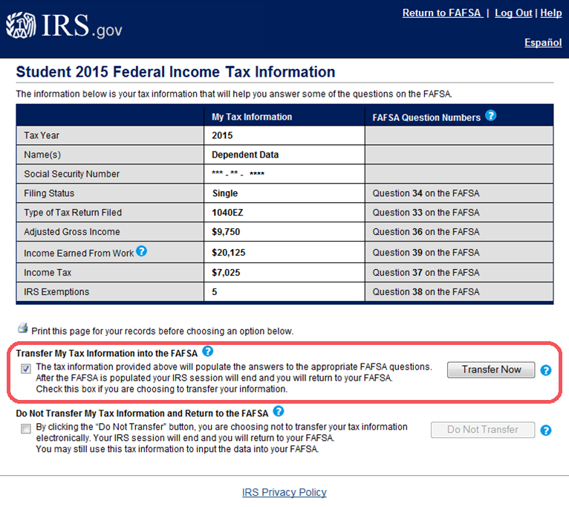
Student and Parent: Here is where you and your parent(s) (if applicable) will provide your financial information. This step is incredibly simple if you use the IRS Data Retrieval Tool, which is available within the FAFSA. This tool allows you to import your IRS tax information into the FAFSA with just a few clicks. Using this tool also may reduce the amount of paperwork you need to provide to your school. So if you’re eligible, use it!

More good news: Since the 2017-18 FAFSA requires earlier (2015) tax information, you’ll have already filed your taxes by the time you start the FAFSA. This means, you’ll be able to transfer your tax information right away and you won’t have to log back in later to update it!
To access the tool, indicate that you’ve “already completed” taxes on the student or parent finances page. Next, the application will determine of you are eligible for the DRT by asking about:
- 1040X Amended tax form
- Puerto Rican or Foreign Tax return
Next, if you’re eligible you’ll see an option to “Link To IRS”.
- Enter FSA ID (or email) and Password
- Click “Link To IRS”
- Enter in address exactly how it is printed on your 2015 tax return info
- Press “Submit”
- Verify information then click “Transfer Now” and checkmark the box
If all the steps are completed correctly the information from the IRS DRT will be placed in the correct fields on the FAFSA. Please continue answering the questions until you get to the students financial information section.
If the student did NOT have a job from 2015-2016 and did NOT file taxes please select the “WILL NOT FILE” option on the drop down menu. If your child did have a job and filed taxes they will need to follow the steps above with their FSA ID and Password to complete the DRT.
Step 8- Sign & Submit
Students and Parents: You’re not finished with the FAFSA until you and your parent (if you’re a dependent student) sign it. The quickest and easiest way to sign your FAFSA is online with your FSA ID.
Note: If you (the student) logged in to the FAFSA with your FSA ID, you won’t need to provide it again on this page, but if you’re a dependent student, your parent will still need to sign before you can completely submit.
Sign and Submit Tips:
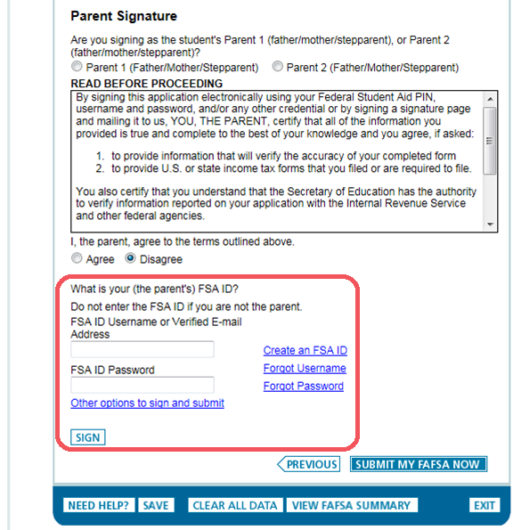
- If you or your parent forgot your FSA ID, you can retrieve it by going to FSAID.ED.GOV and click the “Edit FSA ID” tab
- Make sure you and your parent don’t mix up your FSA IDs. This is one of the most common errors we see, and why it’s extremely important for each person to create his/her own FSA ID and not share it with anyone.
- Make sure the parent who is using his/her FSA ID to sign the FAFSA chooses the right parent number from the drop-down menu. If your parent doesn’t remember whether he/she was listed as Parent 1 or Parent 2, he/she can go back to the parent demographics section to check.
- If you have siblings, your parent can use the same FSA ID to sign FAFSAs for all of his or her children. Your parent can also transfer his/her information into your sibling’s application by choosing the option provided on the FAFSA confirmation page.
- We recommend signing the FAFSA with an FSA ID because it’s the fastest way to get your FAFSA processed. However, if you and/or your parent are unable to sign the FAFSA electronically with an FSA ID, you can mail in a signature page. From the sign and submit page, select “Other options to sign and submit” and then choose “Print A Signature Page.” Just keep in mind that your FAFSA will take longer to process if you go this route.

