 |  | 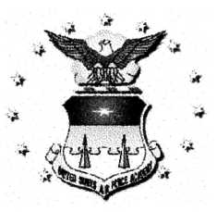 | 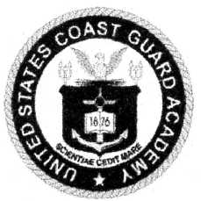 | 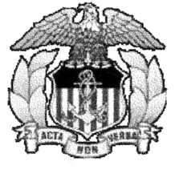
U.S. Military Academy  www.usma.edu | U.S. Naval Academy  www.usna.edu | U.S. Air Force Academy  Academyadmissions.com | U.S. Coast Guard Academy  www.uscga.edu | U.S. Merchant Marine Academy  www.usmma.edu

Local Academy Point of Contact Reps:
Academy | Focal Point | Telephone Nr | Email address
U.S. Military Academy | Mr. Rick de Moya | (910) 769-5237 | rgdemoya@gmail.com
U.S. Naval Academy | Mr. Mike Roberts | (303) 638-7560 | ncbgo9376@gmail.com
U.S. Air Force Academy | Col Brian Doyle | (919) 740-7271 | alo.usafa@gmail.com
U.S. Coast Guard Academy | Mrs. Jeanne Herman | (919) 467-7960 | JeanneHerman@nc.rr.com
U.S. Merchant Marine Academy | ChE Craig Fishbough | (352) 514-5880 | csfishbo@yahoo.com

USMA, USNA, USAFA, and USCGA each have Summer Familiarization Programs
The application process usually includes entering a pre-application, then applying separately to attend the summer program. Signup and program dates for current juniors follows:
Academy | Website
U.S. Military Academy | http://www.usma.edu/admissions/sitepages/summer.aspx
U.S. Naval Academy | http://www.usna.edu/Admissions/Programs/NASS/
U.S. Air Force Academy | http://www.academyadmissions.com/admissions/outreach-programs/summer-seminar/
U.S. Coast Guard Academy | http://www.uscga.edu/AIM/

